Practical Assignment 5: Intelligent Document Search Using Unsupervised Learning
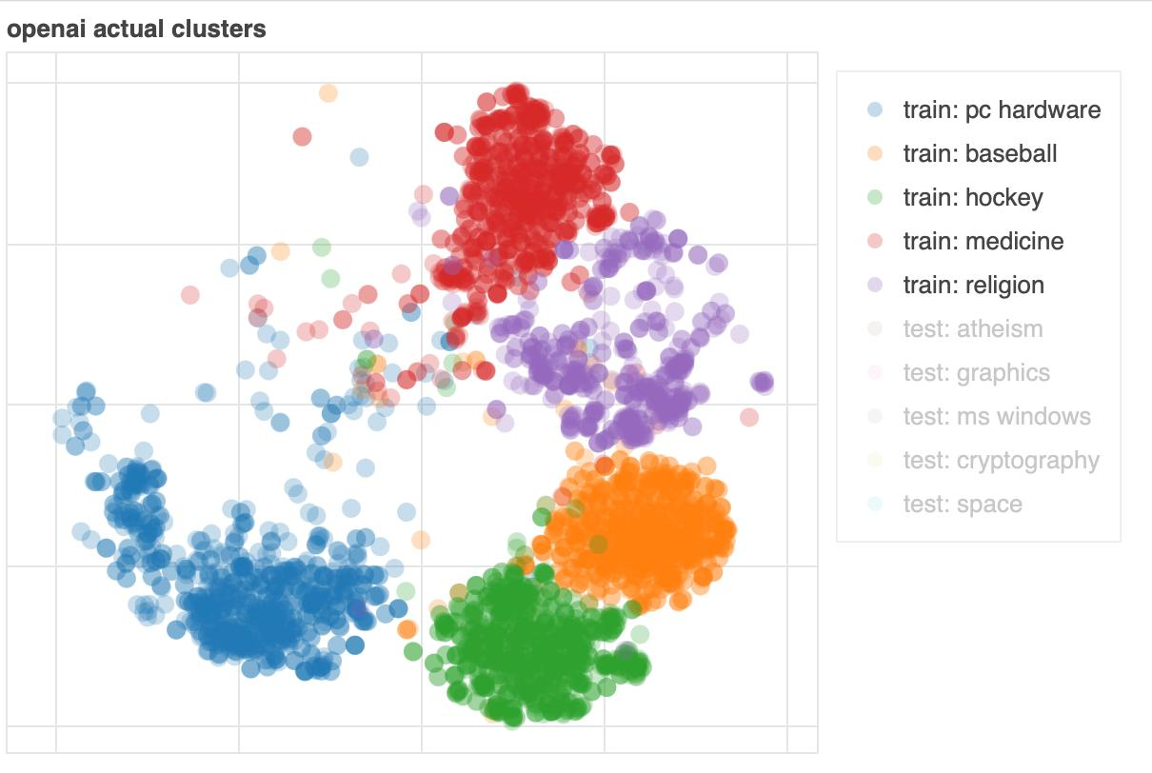
Application: Build an intelligent search system for research papers or college notes.
Problem statement: Design a system that automatically discovers groups of related documents, identifies their topics, and retrieves useful documents without requiring manually labeled training data.

Tasks to perform
- Collect documents: Gather at least 20 documents from three or more subject areas, such as AI, cybersecurity, databases, and networking.
- Generate word embeddings: Represent words or documents as numerical vectors using Word2Vec, GloVe, or a sentence-embedding model.
- Apply clustering: Use K-means or hierarchical clustering to group similar documents automatically.
- Perform topic modeling: Apply Latent Dirichlet Allocation (LDA) or another suitable topic-modeling method to discover the main themes.
- Reduce dimensionality: Use PCA or t-SNE to visualize documents in two dimensions and observe their clusters.
- Detect anomalies: Identify documents that do not fit well into any cluster, such as an unrelated document accidentally added to a collection.
- Build a retrieval interface: Allow users to enter a query and retrieve documents based on semantic similarity or cluster membership.
- Evaluate retrieval quality: Create a small set of relevance judgments and calculate Precision, Recall, or another suitable metric.

Example scenario
Suppose students upload the following documents:
Document | Main subject
D1 | Neural networks and deep learning
D2 | Natural language processing
D3 | Network security and firewalls
D4 | Cryptography and cyberattacks
D5 | Relational databases and SQL
D6 | Database indexing
D7 | A document about gardening
Expected clustering:
- Cluster 1: AI and NLP — D1, D2
- Cluster 2: Cybersecurity — D3, D4
- Cluster 3: Databases — D5, D6
- Potential anomaly: D7, if it is sufficiently dissimilar to the other documents.
Query: “documents about protecting computer networks”
The system should retrieve D3 and D4 based on their content, even if the exact query words do not appear in every document.

Expected output
- Document embeddings or vector representations.
- Automatically generated document clusters.
- Topic summaries for each cluster.
- A 2D visualization of the document collection.
- A list of detected anomalies.
- Search results with an explanation of their relevance.
Concepts covered: Word embeddings, clustering-based retrieval, topic modeling, dimensionality reduction, anomaly detection, and retrieval evaluation.

